The Right Way To Save Money On Moving!

There are things in your life’s that we don’t want to spend money on and Moving is one of them. Why pay money when we can do it ourselves? The answer is to make our life a little bit easier. We have so many things to do and it’s way easier to make professionals do the job for us, even if we have to pay money for it. At the same time nothing can stop you from making it easy and pay less money. And we will tell you how!

Preparation. Preparation is everything when things come to moving. When you are moving its finally time to go thought your precious belongings and think if it’s time to let go of something, cloth you don’t need, furniture you don’t use, maybe its time to buy something new? Its hard to let go but its are right thing to do to save time and money on moving.

Before your movers come, make sure everything is organized and easy for movers to work with. If you have time to do your own packing it will be a big help for your budget. Make sure all the lids are closed and taped, try to bring all the boxes into a big room (living room or garage) somewhere movers can come and take it. After you moved all the boxes, make sure you don’t have anything on top of your dressers, take off your bedding, if you can disassemble your bed or dining table – do it! Unplug all your devices such as Computers and Tv’s, put all the wires in boxes and mark them so you know how to find them. Count all your boxes and furniture peace’s, create a little list of the items and in the end, it will be much easier to make sure everything made it into your new place! All these little things will help you same hundreds of dollars.

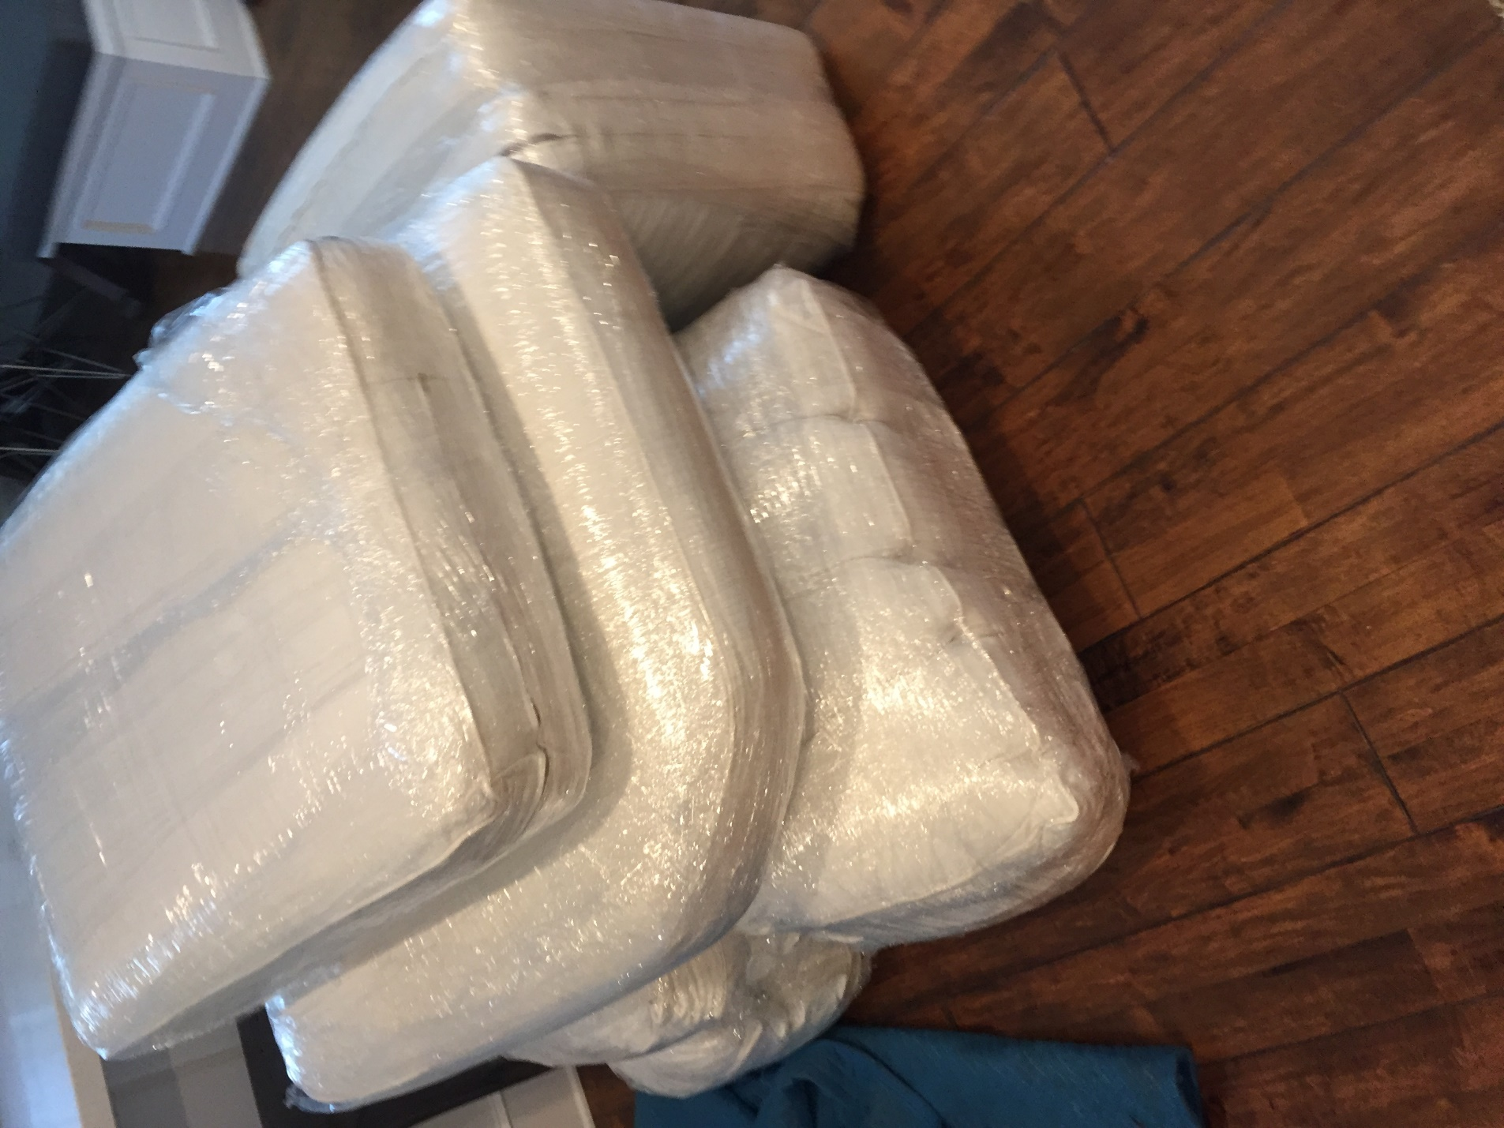

If you want to help movers to carry something outside, its always good to ask first. The movers need to make sure they pack everything properly in the truck and like in Tetris game they need different peace’s to stack them. Having a water for yourself and movers is helpful too!

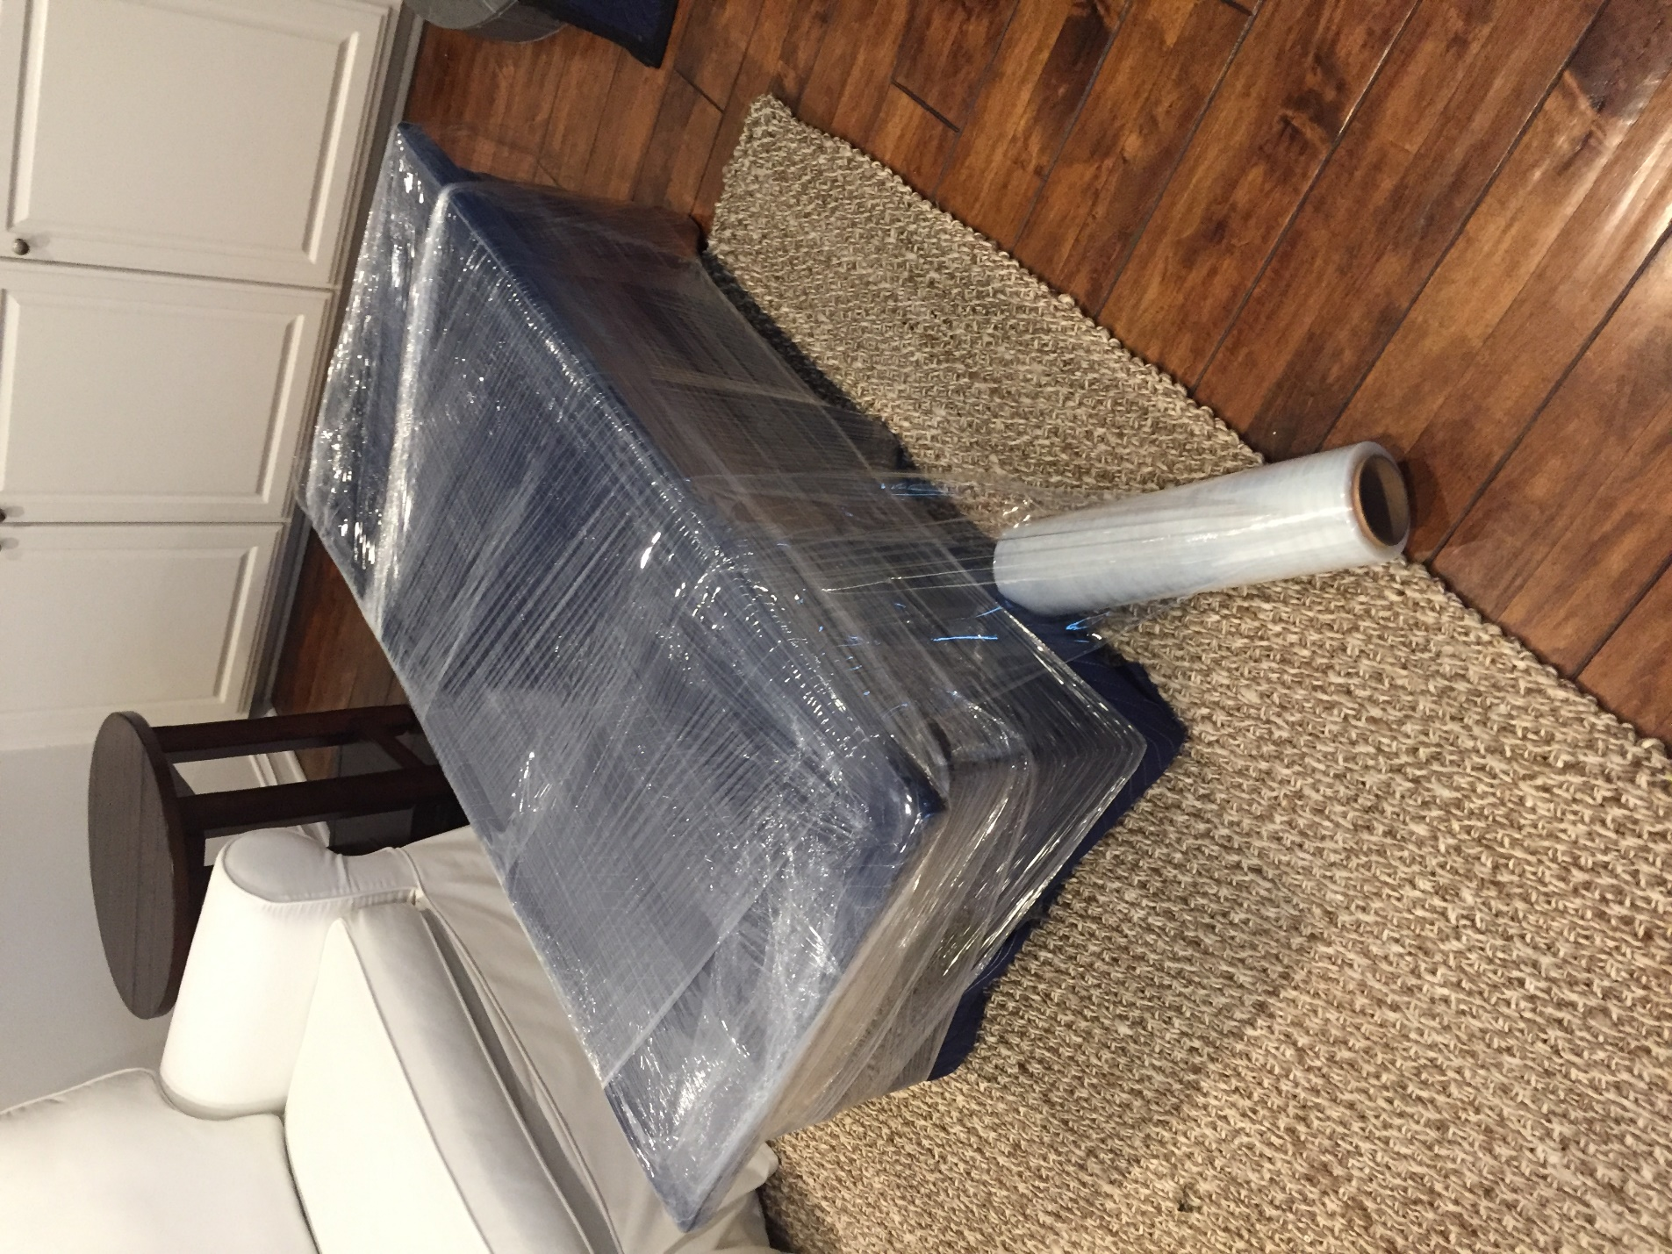Movers are people too and they will appreciate things like this and work harder to make you happy! In the end of the day moving has to be done and we want to get it done right even if it takes more time. The golden rule is “It’s always better to give a time discount than a damage discount“ In most cases trying to hurry the movers not going to help but make it worse.

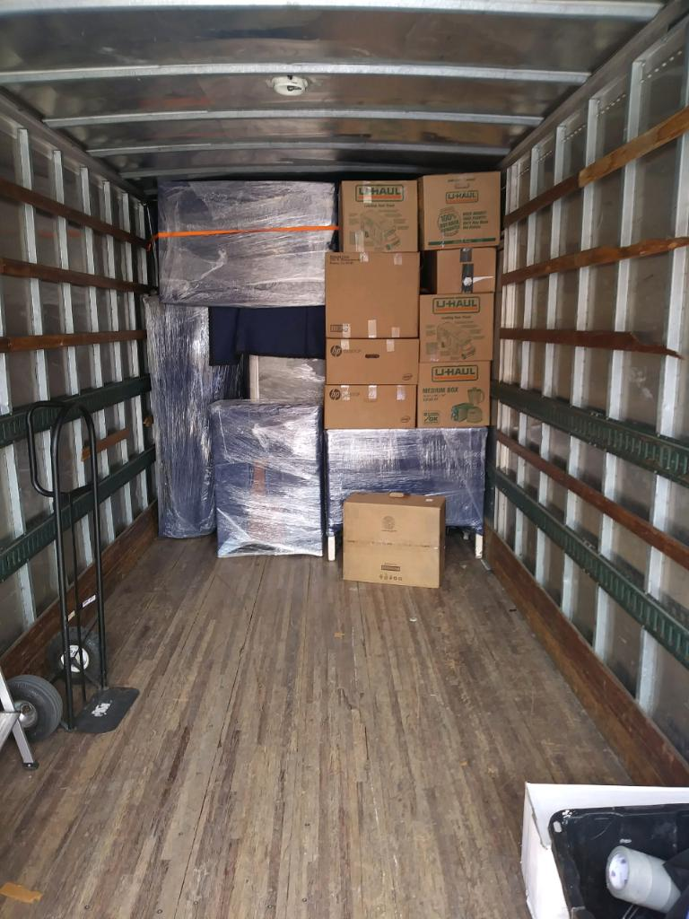

We hope that this article was helpful and you will be able to have great time moving your stuff and paying less money!